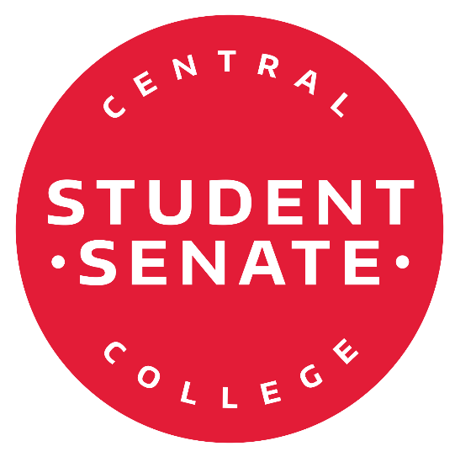

The Student Body President is a very important role at Central College. It takes a great leader with lots of dedication and passion for the position. The Student Body President has many duties. In the Student Senate Constitution, these duties are defined, but not necessarily limited to, the following:

1. Perform all ceremonial duties and speaking engagements.
2. Serve on the Faculty Policy Committee, if available.
3. Serve as a liaison between the college administration, student body, and Student Senate.
4. Serve as a non-voting representative to the Board of Trustees.
5. Serve as a non-voting member to the Executive Committee and Student Senate.
6. Serve as a member of the College Review Panel (CRP).

In order to run, the applicant must provide 25 signatures from students of Central College and one signature of a Central College faculty member. The applicant must also submit a 250+ word personal statement explaining his/her purpose and qualifications for seeking the office of Student Body President at Central College. A letter of academic good standing from the Registrar should be attached to your application when submitted.

Please send your completed **essay** and a **headshot** to hornerj1@central.edu to be used on Blackboard, social media, and fliers. If no headshot is submitted no picture will be attached to the candidate profile.

# Submit your completed application and signatures to Student Development (2nd Floor Maytag Student Center) by 12:00 PM (noon) on Wednesday February 10th, 2021.



**The election will follow the follow the following timeline for elections:**

February 2nd- Applications will be made available in the Office of Student Involvement.

February 10th- Applications are due to Student Development on the 2nd floor of Maytag at 12:00pm.

February 11th- Student Body President forum at 8:00 p.m in the BMW Rooms.

February 12th- Elections will begin on Blackboard at 12:00pm.

February 18th- Elections close on Blackboard at 12:00 midnight.

February 19th – Announcement

***Please review the following before you begin your campaign:***

**Student Body President Campaign Guidelines:**

Printing will be available through the Student Involvement Office, students running for president will be provided **25 standard color copies (8.5” x 11”)** and **2 larger posters up to 11” x 17”** at the expense of the Student Senate. Copies must be made upon approval by student workers in the Office of Student Involvement.

Candidates must behave in an ethical manner towards other candidates and voters. Candidates shall not hamper or prevent the full and free expression of the will of the voters including acts intended to prevent any eligible person from voting.

Candidates shall be respectful of other candidates and refrain from personal attacks on the candidates or others closely associated with candidates.

Candidates and those campaigning on their behalf are asked to remember Central College’s Code of Conduct and the rules regarding student discourse. Any violations to Student Policies will result in judicial action.

Each candidate shall follow school rules about posting fliers around campus.

If posters are removed over the course of the election, new fliers may be printed to replace posters where others were removed.

No additional materials from the Office of Student Involvement should be used in an individual’s campaign for Student Senate.

Central College associated email lists, such as Blackboard email lists, should not be used to send emails regarding a candidate in the election. Only self-generated email lists can be used.

A candidate should not ask any other individual to send emails on their behalf outside of a campaign manager (if abroad you will be permitted a campaign manager to speak on your behalf).

Candidates shall not use any *quid pro quo* methods to gain votes. This means there shall be no giving something of value or benefit in order to influence another student in the act of voting for a specific candidate. General handing out of candy, cookies, or other food, in order to generally encourage voter turnout does not constitute a *quid pro quo* method of gaining votes.

Candidates shall not coerce election help or votes for themselves, including, but not limited to asking for support from faculty or staff who may be in a position of influence/power/authority over students, or have an electronic device provided for voting during campaigns.

Candidates shall be respectful and courteous when campaigning in residence halls and in public areas (i.e. Maytag, Central Market, Roe).

No candidate shall ask for, or receive any campaign contributions from any student or individual.

## Any questions regarding campaign ethics and practices, please be directed to Senate Leader Parker Majerus or Student Senate Advisor Carol Williamson.

**By submitting and signing this application, I agree to follow these election guidelines.**

Signature

Students supporting

(First) (Last)

As the Central College Student Body President during the 2020- 2021 school year:

## 1. 2.

**3. 4.**

**5. 6.**

**7. 8.**

**9. 10.**

**11. 12.**

**13. 14.**

**15. 16.**

**17. 18.**

**19. 20.**

**21. 22.**

**23. 24.**

**25.**

**Central College Faculty Member.**